**FLOWCHART**

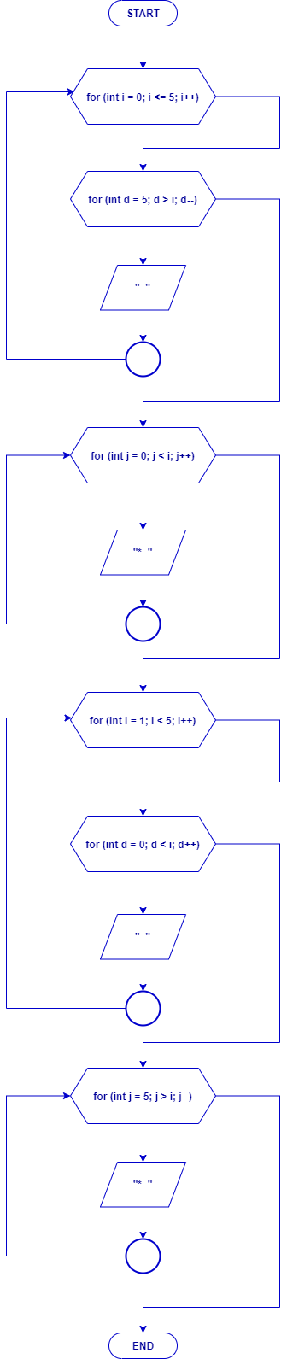

**SOURCE CODE**

**#include <iostream>**

**using namespace std;**

**int main () {**

**cout << "---------------------------------- " << endl;**

**cout << "| Looping Bintang Layang - Layang |" << endl;**

**cout << "-----------------------------------" << endl;**

**cout << endl << endl;**

**for (int i = 0; i <= 5; i++)**

**{**

**for (int d = 5; d > i; d--)**

**cout << " ";**

**for (int j = 0; j < i; j++)**

**cout << "* ";**

**cout << "\n";**

**}**

**for (int i = 1; i < 5; i++)**

**{**

**for (int d = 0; d < i; d++)**

**cout << " ";**

**for (int j = 5; j > i; j--)**

**cout << "* ";**

**cout << "\n";**

**}**

**return 0;**

**}**

**HASIL PROGRAM**

